# Get following errors in Crawl Log for .xps documents

Processing this item failed because of an initialization failure in the IFilter parser.

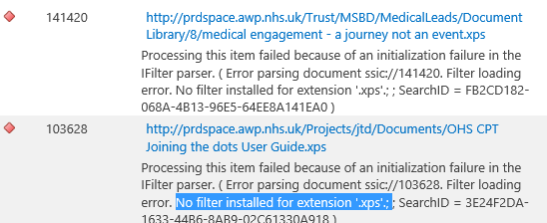

# Diagnosis

There is not ifilter available for the .xps file type

See:

[Default crawled file name extensions and parsed file types in SharePoint Server](https://docs.microsoft.com/en-us/sharepoint/technical-reference/default-crawled-file-name-extensions-and-parsed-file-types)

# Resoution

Remove .xps from the [list of file types in the search index in SharePoint Server](https://docs.microsoft.com/en-us/sharepoint/search/add-or-remove-a-file-type-from-the-search-index)

Run PowerShell script “Remove xps filetype.ps1”